CSIT314 Software Development Methodologies - Group Project

Sprint 5 - US46: Generate daily report
Interior Design Platform - Platform Manager
All diagrams were drawn in draw.io. Open "US46 Generate daily report.drawio" in this folder to edit them - each diagram is its own page in that file. The exported images are in the "diagrams" folder.

Assumptions
- The system is the Interior Design Platform from the project specification. Sprint 5 covers the Interior Designer's IDP view and save statistics (US37, US38) and the Platform Manager's daily, weekly and monthly IDP category reports (US46 - US48).
- We follow B-C-E: the actor only talks to the boundary (page), the boundary only talks to the controller, and the controller works with the entity classes. There is one controller per use case.
- Who checks what: the boundary checks all the input (required fields, lengths, formats, e.g. not suspending your own profile) and trims spaces, then passes an entity object on. The controller just calls the entity and returns the result. The entity checks for duplicates and the database state (e.g. name already used, only Active rows are changed), then saves. In US46 the only input is the date: the page trims it and checks it (validateDate - a real YYYY-MM-DD date, checked with datetime.strptime(selectedDate, "%Y-%m-%d") so 20261105 is rejected, and not after today). The controller just calls IDPAnalytics.getDailyReport(selectedDate) and returns the report unchanged. The entity works out the period itself and reads the views and saves; nothing is saved.
- Being logged in as a Platform Manager (UC39) is the precondition, so the page and the B-C-E / sequence diagrams don't check the manager again (no PlatformManagerLoginController). managerLoginRequired in app.py only sends someone with no session to /manager/login.
- Views are recorded when a customer opens an IDP (UC32 View IDP) and saves when a customer saves one (UC33 Save IDP). The report only reads them; it never changes any data.
- The report lists every IDP category, Active or Suspended, with its number of Active IDPs and the views and saves of its IDPs in the period (both ends included), ranked by views, then saves (then name). Times are stored in UTC and compared as local dates.
- A daily report covers one day: the day the Platform Manager picks (it can't be after today). The date box starts on today.
- Daily, Weekly and Monthly tabs on the same page switch between US46, US47 and US48. "Reports" in the side menu opens the daily report; the dashboard links to all three.
- Wrong input never reaches the controller: a date that isn't a real YYYY-MM-DD date gives "Please choose a valid date" and a date after today gives "The date can't be in the future" (HTTP 400, the form is shown again). A period with no views and no saves still shows the table (all zeros) with "No IDPs were viewed or saved in this period".

1. User story
Story ID | US46
User story | As a platform manager, I want to generate a daily report so that I can see which IDP categories were most popular on a selected day.
Actor | Platform Manager
Priority | To be agreed
Story points (estimate) | To be agreed
Acceptance criteria | 1. Given I am logged in as a platform manager, when I click "Reports" in the side menu, then I see the Daily Category Report page with a date box ("Day") that starts on today, and no report yet.  2. Given I pick a day and click "Generate report", then I see "Period:" with that day and every IDP category (Active or Suspended) with its status, number of Active IDPs, views and saves on that day.  3. The categories are ranked by views, then saves.  4. Given no IDP was viewed or saved in the period, then I see "No IDPs were viewed or saved in this period" and the table with zeros.  5. Given the date is not a real date (e.g. 2026-02-30 or 20261105), then I see "Please choose a valid date" and no report.  6. Given the date is after today, then I see "The date can't be in the future" and no report.  7. Given I am not logged in, when I open the report page, then I am sent to the manager login page.
Tasks | #264 Draw Use Case Diagram and Write Use Case Description  #269 Design Wireframe  #274 Write and Execute Test Cases  #279 Draw BCE and Sequence Class Diagram  #285 Develop the daily report function to retrieve and display IDP category popularity statistics for a selected date.

2. Use case diagram
The user story becomes one use case, UC46 Generate daily report. The Platform Manager is the only actor. Being logged in (UC39) is the precondition; the views and saves the report counts are recorded by UC32 View IDP and UC33 Save IDP. UC46, UC47 and UC48 are the daily, weekly and monthly reports on the same page.
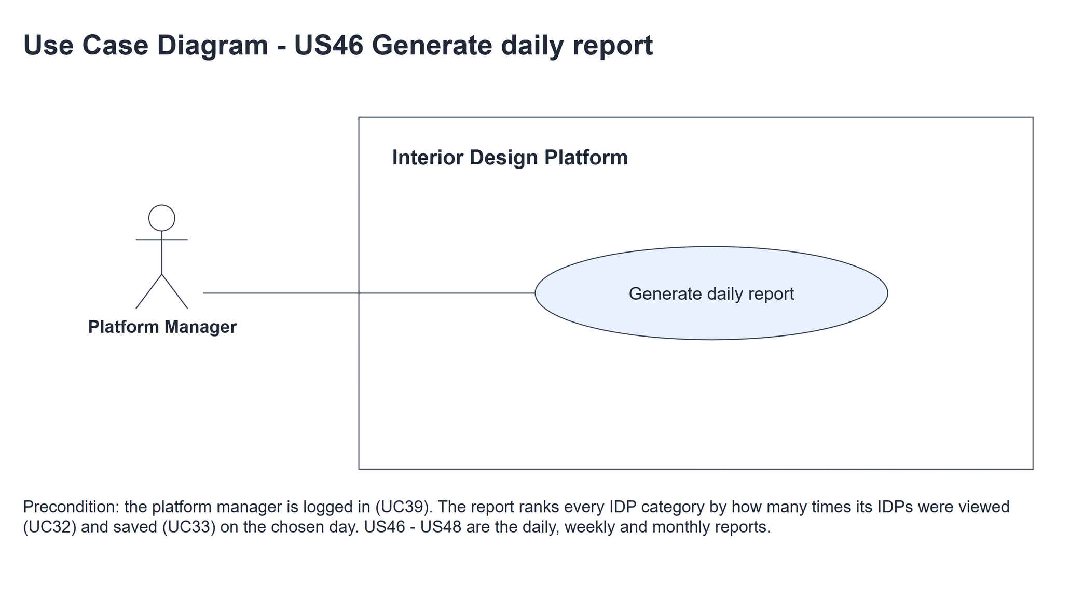
Figure 1: Use case diagram for US46 Generate daily report

3. Use case description
Use case | UC46 Generate daily report
Actor | Platform Manager
Brief description | The Platform Manager picks a day and sees which IDP categories customers viewed and saved most on that day.
User story | US46: As a platform manager, I want to generate a daily report so that I can see which IDP categories were most popular on a selected day.
Preconditions | Logged in as a Platform Manager (UC39). managerLoginRequired in app.py only sends someone with no session to /manager/login.
Trigger | The Platform Manager clicks "Reports" in the side menu (or the Daily tab on the report page).
Basic flow | 1. The Platform Manager clicks "Reports" in the side menu.  2. The system shows the report form; the date box starts on today.  3. The Platform Manager picks a day in the date box and clicks "Generate report".  4. The system trims the date and checks that it is a real YYYY-MM-DD date that is not after today.  5. The system works out the period from the date - just that day.  6. The system counts the views and saves of every IDP category in the period and ranks the categories by views, then saves.  7. The system shows the period and the ranked table with each category's status, number of Active IDPs, views and saves.
Alternative flows | 4a. The date is not a real YYYY-MM-DD date (e.g. 2026-02-30 or 20261105): the system shows "Please choose a valid date" with the form again (HTTP 400). No report is generated. The use case ends.  4b. The date is after today: the system shows "The date can't be in the future" with the form again (HTTP 400). No report is generated. The use case ends.  7a. No IDP was viewed or saved in the period: the system shows the period, "No IDPs were viewed or saved in this period" and the table with zeros.
Postconditions | The report (or the error message) is shown. No data is changed.

4. Wireframes
The wireframes were drawn in draw.io. They are low-fidelity: they show the layout and the flow, not the final colours. They follow platformManagerBase.html, idpCategoryReport.html and static/style.css. The orange numbers match the notes under each screen.

4a - Date form
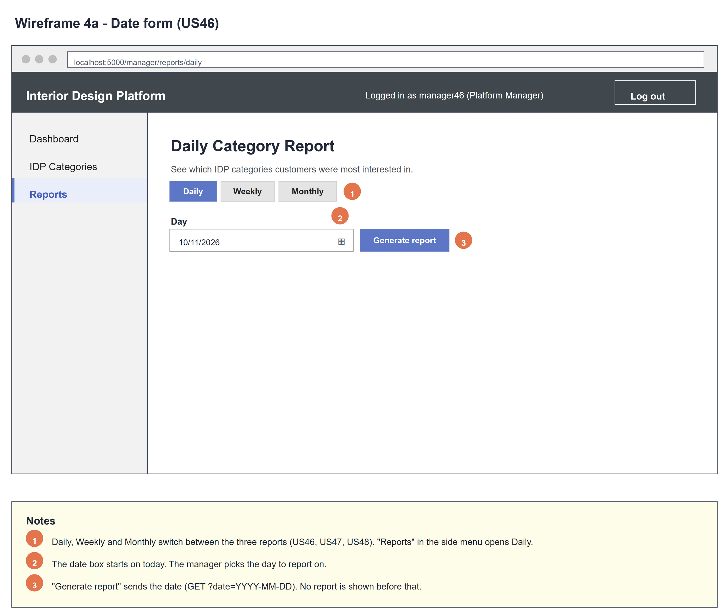
Figure 2: Wireframe 4a - Date form (US46)

4b - Report
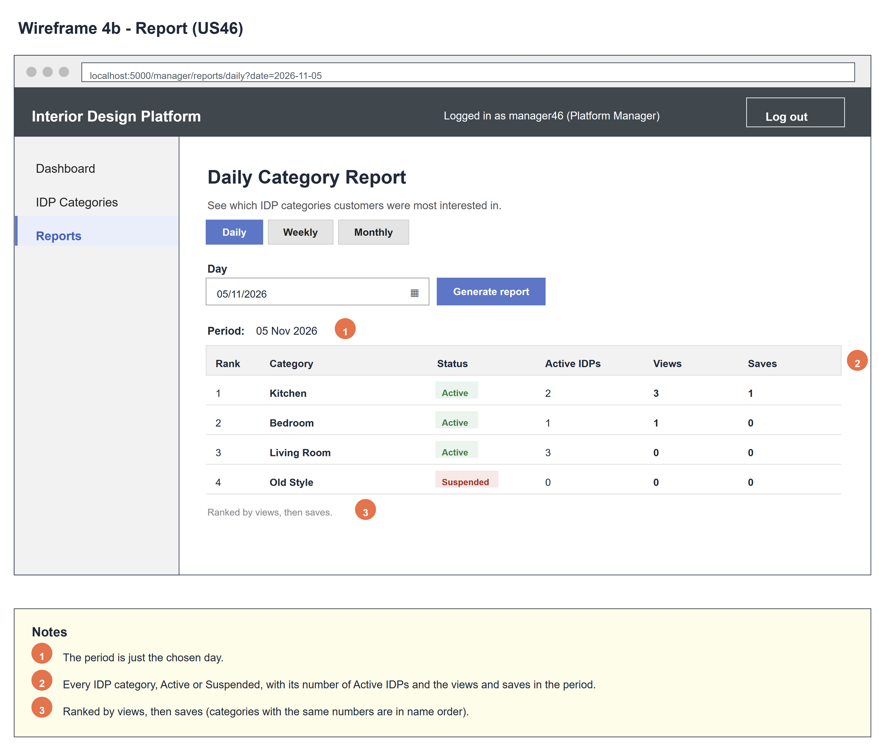
Figure 3: Wireframe 4b - Report (US46)

4c - No activity
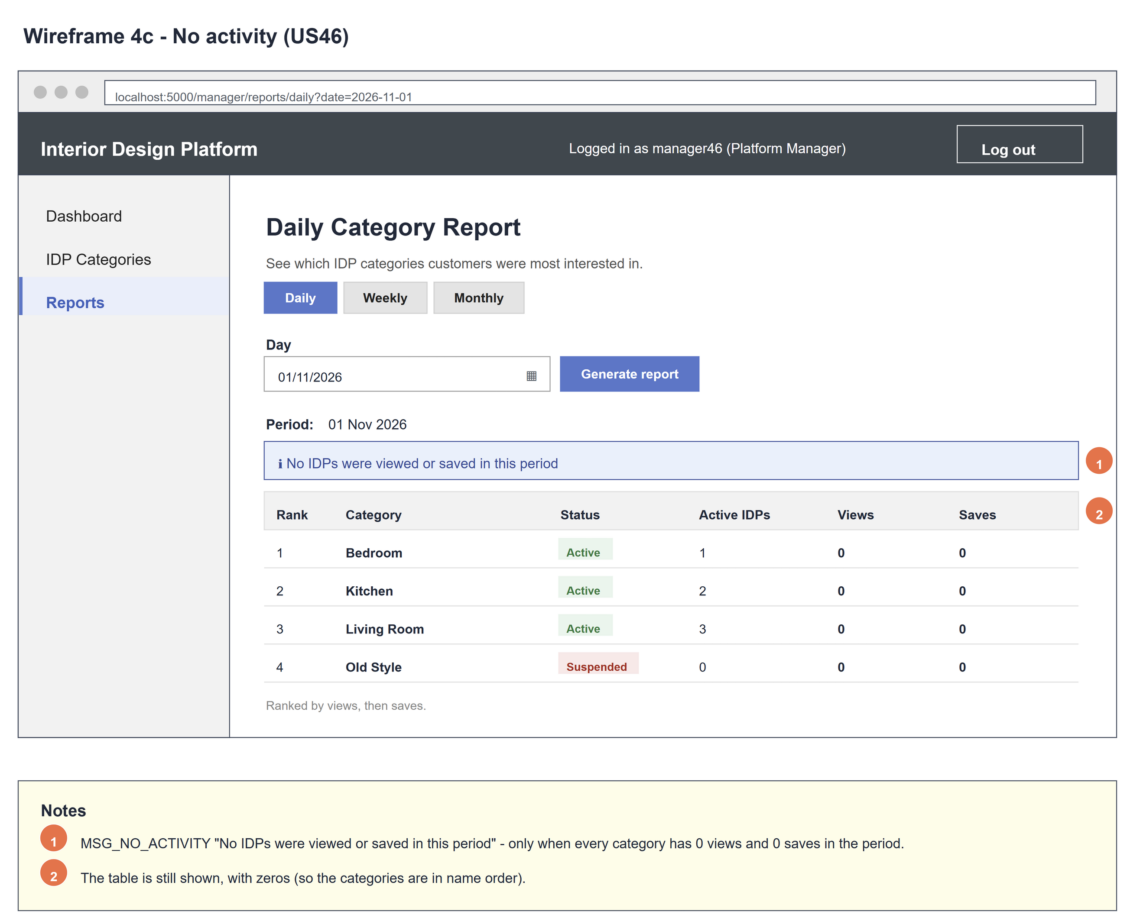
Figure 4: Wireframe 4c - No activity (US46)

4d - Invalid date
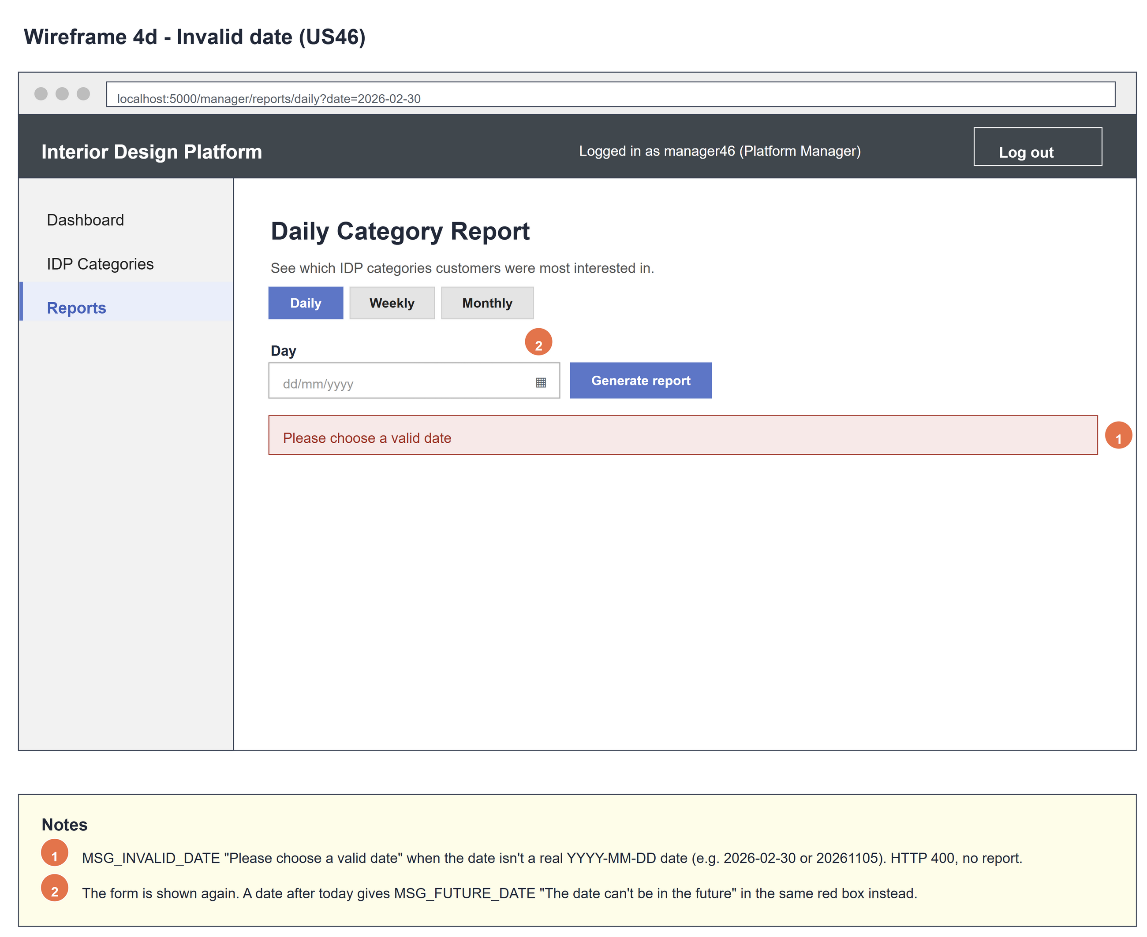
Figure 5: Wireframe 4d - Invalid date (US46)

5. B-C-E class diagram
The solid line means the boundary calls the controller. The dashed line means the controller uses the entity. Only the operations needed for this use case are shown. IDPAnalytics has the same attribute list in every Sprint 5 B-C-E diagram (US37, US38, US46 - US48): a report uses startDate, endDate and categories, and each category row uses categoryId, categoryName, status, totalIDPs, views and saves.
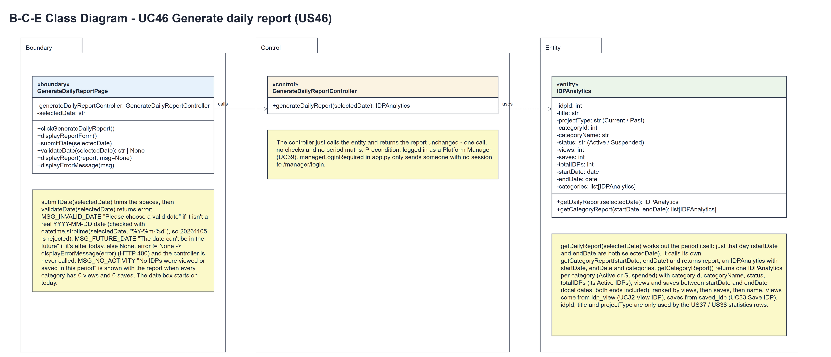
Figure 6: B-C-E class diagram for US46 Generate daily report
Layer | Class | What it does
Boundary | GenerateDailyReportPage | The Daily Category Report page. clickGenerateDailyReport() shows displayReportForm() with the date box on today. submitDate(selectedDate) trims the date and calls validateDate(selectedDate), which returns error (MSG_INVALID_DATE, MSG_FUTURE_DATE or None). An error -> displayErrorMessage(error) (HTTP 400) and the controller is not called. Otherwise it calls generateDailyReport(selectedDate) and shows displayReport(report), or displayReport(report, MSG_NO_ACTIVITY) when every category has 0 views and 0 saves.
Control | GenerateDailyReportController | Controller for UC46. generateDailyReport(selectedDate) just calls IDPAnalytics.getDailyReport(selectedDate) and returns the report unchanged - one call, no checks, no period maths.
Entity | IDPAnalytics | The only entity. getDailyReport(selectedDate) works out the period (just that day), calls its own getCategoryReport(startDate, endDate) and returns report: an IDPAnalytics with startDate, endDate and categories (a list[IDPAnalytics], one per category with categoryId, categoryName, status, totalIDPs, views and saves, ranked by views, then saves, then name).

6. Sequence diagram
The sequence diagram follows UC46. Opening the page (steps 1-3) shows the date form. submitDate(selectedDate) (step 4) runs validateDate(selectedDate) (step 5), which returns error. Outer alt [error == None]: the page calls generateDailyReport(selectedDate) (step 6) and the controller makes one call, getDailyReport(selectedDate) (step 7); the entity works out the period (just that day) and calls its own getCategoryReport(startDate, endDate) (step 8), and the report comes back unchanged (steps 9-10). The inner alt shows the ranked report (steps 11-12) or the report with MSG_NO_ACTIVITY (steps 13-14, alternative flow 7a). [error != None]: displayErrorMessage(error) and HTTP 400 (steps 15-16, alternative flows 4a and 4b) - the controller is never called.
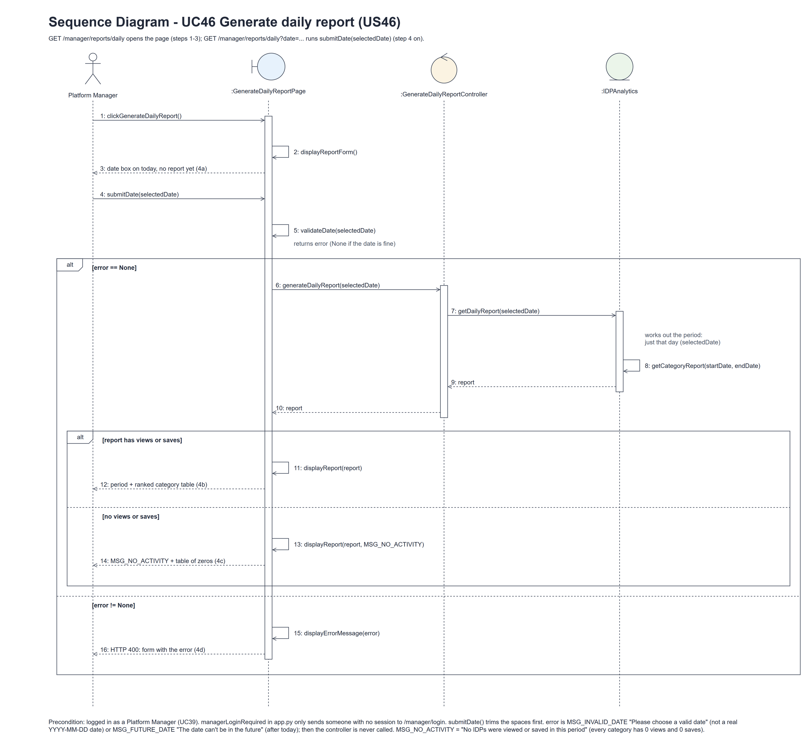
Figure 7: Sequence diagram for UC46 Generate daily report

7. Test cases
Test data used below (the same as tests/test_us46_generateDailyReport.py, which reuses the US37 helpers): the manager account manager46 / Manager@123 (Platform Manager profile) and the designer designer37 / Design@123, both made with UC8. IDP categories Kitchen, Bedroom and Bathroom (Active). The IDPs "Modern Kitchen" (Kitchen) and "Cozy Bedroom" (Bedroom, Past). Views and saves are stored with UTC times: on 5 Nov 2026 Modern Kitchen has 3 views and 1 save (by cust001) and Cozy Bedroom 1 view, and Cozy Bedroom has 1 more view on 4 Nov 2026. Bathroom has none. Tests use an isolated database.

7a. System test cases (black box)
Equivalence partitioning and boundary value analysis were used to pick the test data. Fill in "Actual result" and "Pass/Fail" after running each test.
Test ID | Scenario | Prerequisites | Test steps | Test data | Expected result | Actual result | Pass / Fail
TC46.1 | Open the daily report | Logged in as manager46. | 1. Click "Reports" in the side menu | - | "Daily Category Report" with the Daily tab selected and the date box on today; no table yet.
TC46.2 | Generate a daily report | Test data above. | 1. Pick 05/11/2026  2. Click "Generate report" | 2026-11-05 | "Period: 05 Nov 2026"; Kitchen (3 views, 1 save), then Bedroom (1, 0), then Bathroom (0, 0).
TC46.3 | Only that day counts | Test data above. | 1. Generate the report for 04/11/2026 | 2026-11-04 | Bedroom first with 1 view; Kitchen 0 views and 0 saves.
TC46.4 | Tie on views | Kitchen and Bedroom have 1 view each on 5 Nov; Bedroom also 1 save. | 1. Generate the report for 05/11/2026 | 2026-11-05 | Bedroom is above Kitchen (more saves).
TC46.5 | No activity | Categories exist; nothing was viewed or saved on 1 Nov. | 1. Generate the report for 01/11/2026 | 2026-11-01 | "No IDPs were viewed or saved in this period" and the table with zeros.
TC46.6 | Not a real date | Logged in as manager46. | 1. Open /manager/reports/daily?date=2026-02-30 | 2026-02-30 | HTTP 400 "Please choose a valid date"; no report.
TC46.7 | Wrong date format | Logged in as manager46. | 1. Open /manager/reports/daily?date=20261105 | 20261105 | HTTP 400 "Please choose a valid date"; no report.
TC46.8 | Future date | Logged in as manager46. | 1. Generate the report for tomorrow | tomorrow's date | HTTP 400 "The date can't be in the future"; no report.
TC46.9 | Today (boundary) | Logged in as manager46. | 1. Click "Generate report" with the date box left on today | today's date | The report for today is shown (no error).
TC46.10 | Not logged in | Not logged in. | 1. Open /manager/reports/daily | - | The manager login page is shown.

7b. Unit test cases (for TDD)
These are written before the code (test-driven development) and run automatically in the CI pipeline. They cover normal inputs, abnormal inputs and boundary values. Each one matches a test function in tests/test_us46_generateDailyReport.py (UT46.1 is test_ut46_1_...). Controller means GenerateDailyReportController; Boundary means GenerateDailyReportPage. "Pass" is from the pytest run on 10 November 2026.
Test ID | Class and method | Input / setup | Expected output | Type | Pass / Fail
UT46.1 | IDPAnalytics.getCategoryReport(startDate, endDate) | Test data; 5 Nov to 5 Nov 2026 | A list[IDPAnalytics] read as attributes: Kitchen (views 3, saves 1), Bedroom (1, 0), Bathroom (0, 0) in that order | Normal | Pass
UT46.2 | IDPAnalytics.getCategoryReport(startDate, endDate) | Test data; 4 Nov to 4 Nov, then 6 Nov to 6 Nov | 4 Nov: Bedroom first with views 1; 6 Nov: the first category has views 0 | Boundary | Pass
UT46.3 | IDPAnalytics.getCategoryReport(startDate, endDate) | Kitchen and Bedroom 1 view each; Bedroom 1 save | Bedroom before Kitchen (tie on views -> more saves first) | Normal | Pass
UT46.4 | IDPAnalytics.getCategoryReport(startDate, endDate) | Kitchen: 2 Active IDPs and 1 Suspended IDP; category Old Style is Suspended | Kitchen.totalIDPs is 2; Old Style is listed with status "Suspended" | Normal | Pass
UT46.5 | IDPAnalytics.getCategoryReport(startDate, endDate) | One view at 20:00 UTC on 5 Nov 2026 | Counted only on the local date of that time | Boundary | Pass
UT46.6 | Controller.generateDailyReport(selectedDate) | 5 Nov 2026 | Makes one call to IDPAnalytics.getDailyReport(selectedDate) and returns that report unchanged | Normal | Pass
UT46.7 | Boundary.clickGenerateDailyReport() (GET) | GET /manager/reports/daily | The date box holds today's date; no table | Normal | Pass
UT46.8 | Boundary.submitDate() (GET ?date=2026-11-05) | Test data | HTTP 200, "05 Nov 2026" (one date, no "to"), Kitchen above Bedroom above Bathroom | Normal | Pass
UT46.9 | Boundary.validateDate() / displayErrorMessage() | ?date=2026-02-30 | HTTP 400, MSG_INVALID_DATE, no table | Abnormal | Pass
UT46.10 | Boundary.validateDate() / displayErrorMessage() | ?date=tomorrow's date | HTTP 400, MSG_FUTURE_DATE | Abnormal | Pass
UT46.11 | Boundary.displayReport(report, MSG_NO_ACTIVITY) | Only an empty Kitchen category; ?date=2026-11-05 | MSG_NO_ACTIVITY and Kitchen in the table | Boundary | Pass
UT46.12 | /manager/reports/daily (managerLoginRequired) | Not logged in | Redirects to /manager/login | Abnormal | Pass
UT46.13 | Dashboard and side menu | GET /manager/dashboard and /manager/categories | Links to /manager/reports/daily, /weekly and /monthly | Normal | Pass
UT46.14 | IDPAnalytics.getDailyReport(selectedDate) | Test data; 5 Nov 2026 | An IDPAnalytics report: startDate and endDate both 5 Nov 2026, categories = getCategoryReport(5 Nov, 5 Nov) (Kitchen 3 / 1 first) | Normal | Pass
UT46.15 | Boundary.validateDate(selectedDate) | "20261105"; "2026-W45-4"; "2026-11-05" | MSG_INVALID_DATE; MSG_INVALID_DATE; None (strict YYYY-MM-DD) | Abnormal | Pass
UT46.16 | Boundary.displayReport(report) (GET ?date=2026-11-05) | Test data (Kitchen has views) | The ranked table is shown and MSG_NO_ACTIVITY is not (only when every category has 0 views and 0 saves) | Normal | Pass

